Forgiveness Platform – Tips and Tricks
MBC will provide instructions via an email from ppploanforgivenessadmin@midwestbankcentre.com on how to begin the forgiveness process. The email will include a link to the digital forgiveness application(s) and client portal.
To access your account you will need the following information*:
- Username – your email address
- Loan Amount – Can be found on your loan agreement
- Loan Account Number – Can be found on your loan agreement
* If you have difficulty logging in, please contact your relationship manager.
Once in the platform, below are several helpful tips to assist you through the forgiveness process.
- Please review the instructions tied to your respective form. As you navigate through the portal, instructions and help text can be reviewed by clicking on the next to the field text.
- All fields with an (*) must be completed before the application can be submitted.
- If you have portal-related questions, please utilize the “Contact Us” feature in the bottom tool bar within the portal.
- If you plan to complete the Form 3508, there is an Excel download “PPP Loan Forgiveness Schedule A Worksheet” within the platform to assist with your forgiveness calculation. Detailed instructions are included in the worksheet on the first tab. The last tab in the workbook “Sched A Values for Portal Inputs” summarizes the amounts that will be input into the platform. If you are utilizing the Form 3508EZ, no spreadsheet is provided nor is required.
- Below is your forgiveness application status bar, which is located at the top of the portal. This will be utilized to track your progress as you complete your application. As you complete a section, a blue circle with a check will be shown as illustrated below. If a section is not complete, the circle will remain unchecked as illustrated within the “Summary” section below. Please note that if not all required fields in a particular section are completed, the status will remain unchecked.
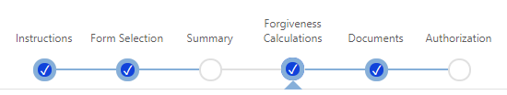
- Forgiveness Calculation Section: You must click “Save” for your forgiveness amount to calculate.
- Within the Documents Section: Please upload the appropriate documentation as detailed within the platform. Make sure you verify the documents have been properly uploaded. Please properly label your documents and upload them to the appropriate folders. Please ensure your documents agree and are clearly mapped to the forgiveness calculation. If we are unable to agree the amounts, your forgiveness application will be returned to you for proper revisions. This will affect the timing of your potential forgiveness approval.
- Once you submit your application, the application is locked and no further changes can be made to the platform. If changes are required, please send a request through your relationship manager who will facilitate unlocking the application for you.
- Once you have submitted your application, you will receive an email that will provide a link to allow you to view the status of your application at any time. See example below.
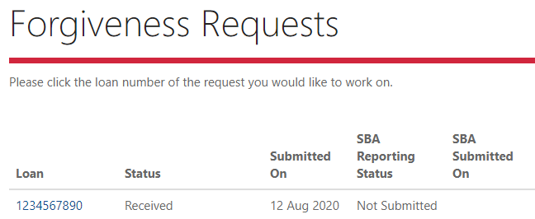

- Our team will review the application to confirm your information and documentation and provide a decision within 60 days as required under the regulation.

